So far we have seen how to connect our real device/Emulators using Appium. In this session we will focus on how to inspect an object/Element using Appium Inspector.

As I already mentioned in one of my previous blog that, the most important and powerful feature in Appium is Inspector. Because it will help us to find an element and its attributes in simple manner. The Inspector screen is simple and lightweight. One can easily inspect an element and the hierarchy model displayed for the screen will be quite interesting.

Salient features of Inspector:
- The hierarchy view of elements
- Just a click on preferred element to inspect that
- You can easily find the element coordinates
- You can Tap on a button and send values to any text field using “Tap” and “Send Keys” button
- Allows to save and modify the Desired Capabilities for future use
- On successful element inspection attributes like “Name”, “Value”, “Label”, “ID”, “XPath” etc.. will be displayed separately in a tabular column
- There are lot of element finding strategy available to search an element like “ID”, “Xpath”, “Class Name”, “UIAutomator Selector”, “Class Chain”, “NSPredicate” etc..

There is a link given to get the list of all applicable “Desired Capabilities”

Now let’s enter into the practical way of Inspecting Elements. Please follow the below steps,

Step 1: To inspect an element we need to know how to enter Desired Capabilities and how to launch the Appium session. If not then please refer to my previous blogs for details.

All set and connection is established successfully, Once you started seeing the mobile phone screen on your Appium Inspector screen you can start spying the elements.

For this tutorial I have selected “JetAudio” media player application. You can select any of your preferred application. Come let’s see how to inspecting Elements for XCUI.

My Desired Capabilities are

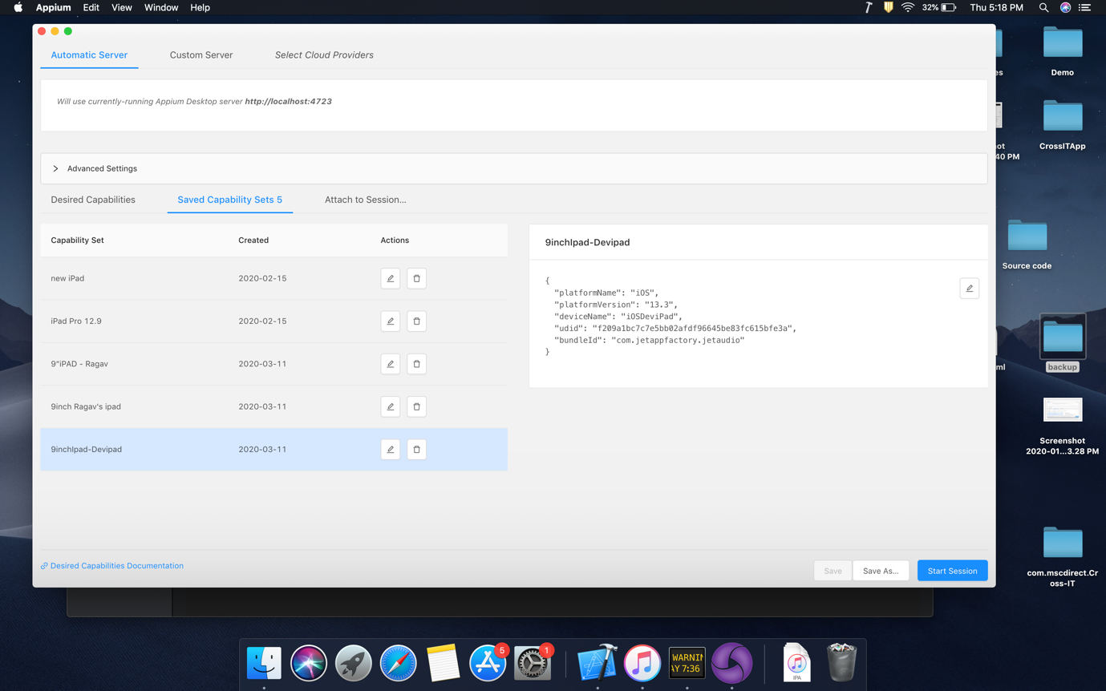
I have selected “Start Session” and my connectivity established successfully. So that you can see my mobile phone screen on Inspector.

Take a look on how the “App Source” is getting displayed here. There are two entries in the name of “XCUIElementTypeWindow”. The 1st entry is the entire application frame and the second entry is for the footer section (the advertisement that is displaying in the footer). You can expand the 1st row to find out all the parent and child elements of the selected screen.
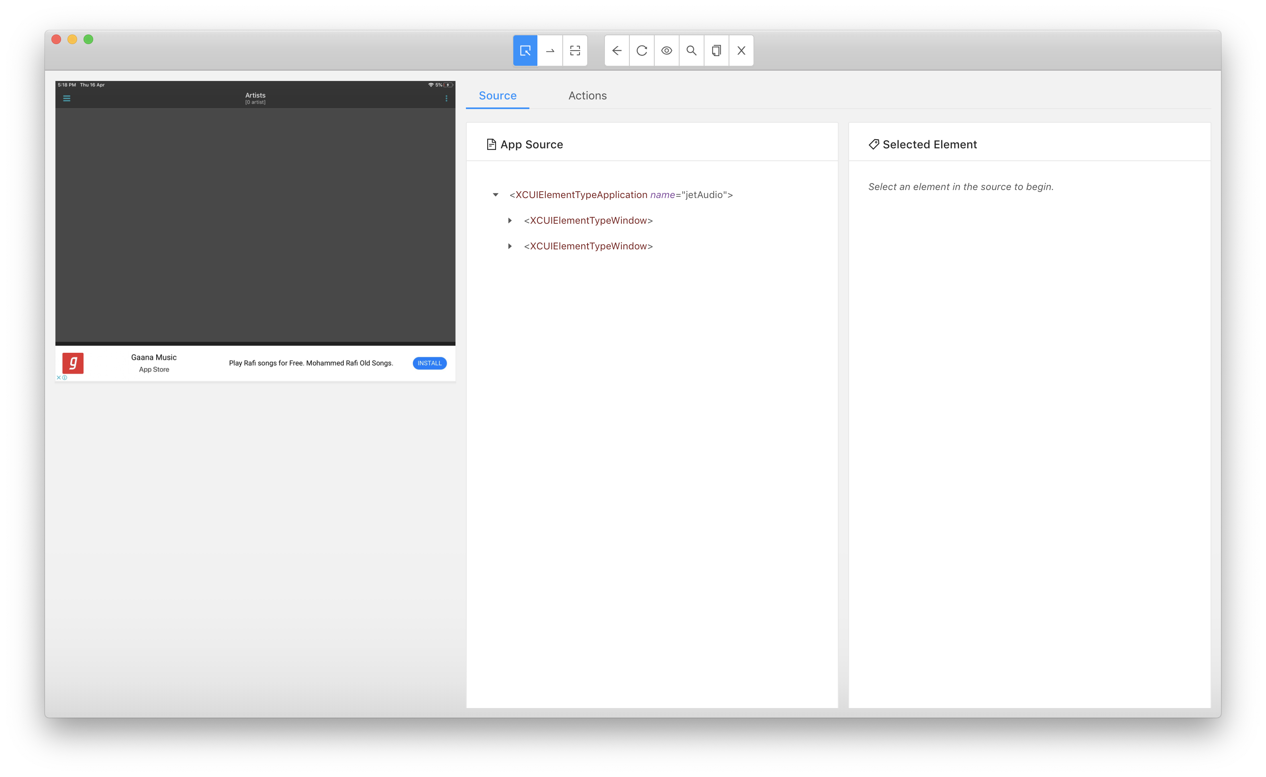
See the expanded view of App source, the splendor here is all the <tags> displaying in the App Sources are nothing but a Class Name of an element/frame. Impressive right ?
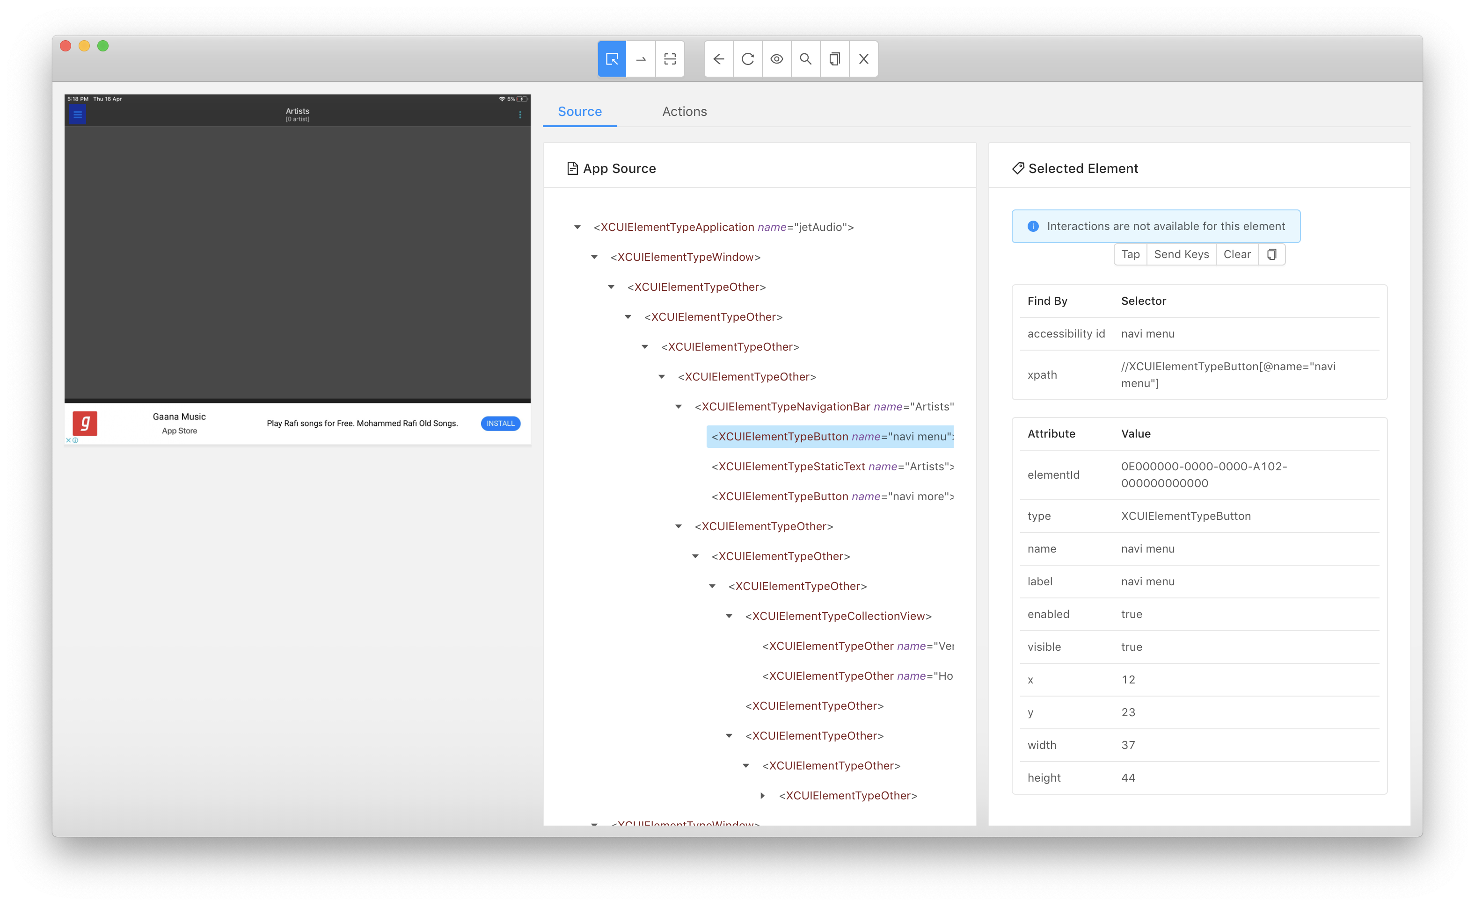

You can also see that selected element Attributes are getting displayed in the right side view of Inspector. This is why I have mentioned it is one a powerful feature of Appium.

Okay all fine. I can see all the attributes of the element… But my question is How to inspect an element? how can I do that?
Yes, let me clarify. Once you can see the app view in Inspector, All you need to do is just a click on the chosen element. For example in the below screen shot, I can see the home page of jetaudio player and I have simply clicked on the Hamburger icon (blue highlighted).
On click of the element, Appium will automatically detects and display’s all the attributes of the element including xpath. It will also display the hierarchical view in “App Source” like below.
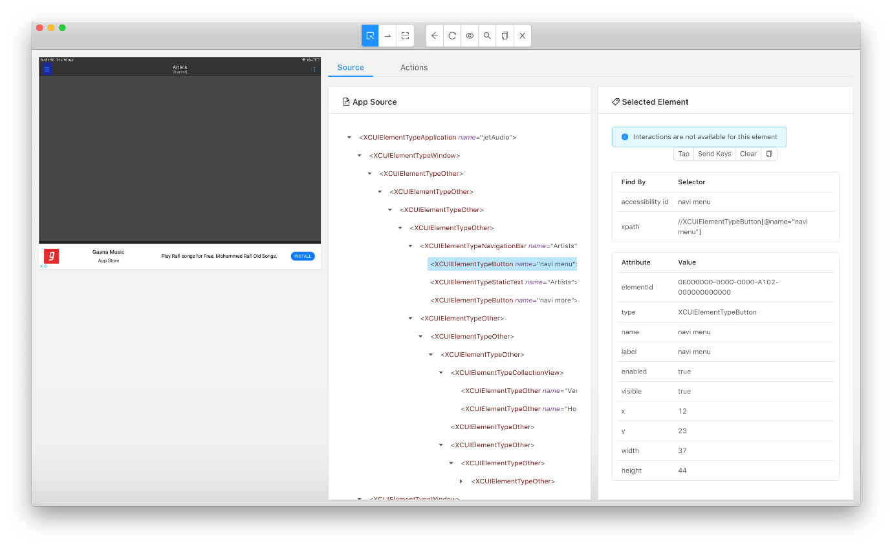
Now we have all the attributes in hand, with the help of these attributes we can easily write location strategies in our code. Easy right ? For example the screen shows the “accessibility id” as “navi menu” so that I can write my location identification strategy using “ID”.

driver.find_element_by_id(‘navi menu’) or driver.findElementById(“navi menu”);

Simple right? Okay now we will see how to find element using locator? finding an element using locator made simple in Appium. Clicking on the icon “Search for elements” will give you list of locators applicable to use with selenium.

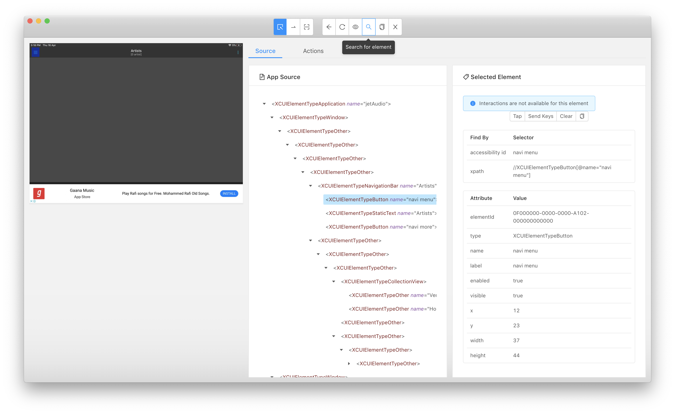
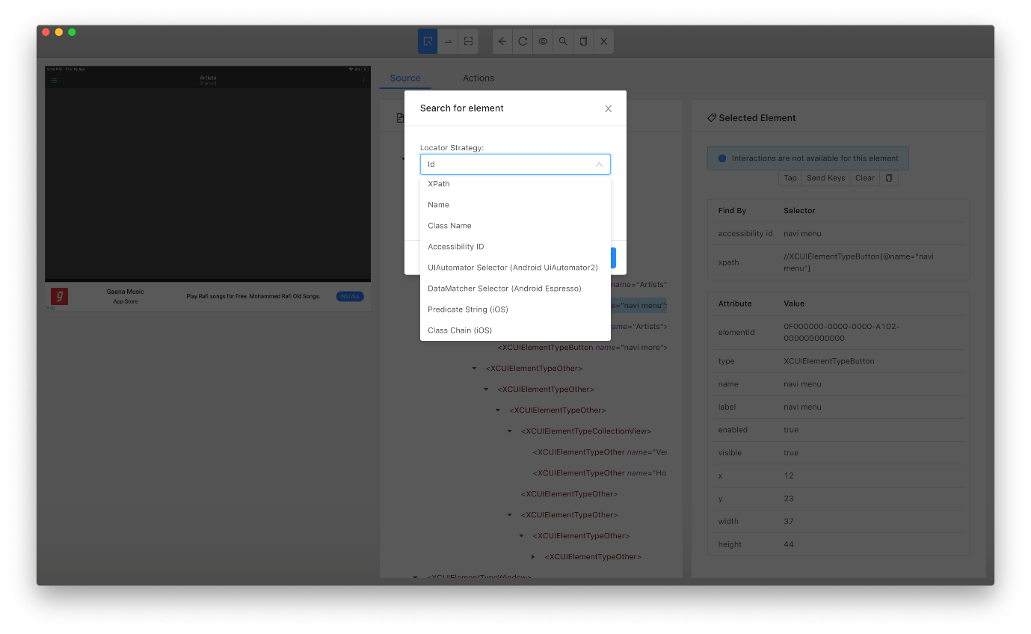
Select the needed locator strategy and enter the Selector (value) in the screen and click on “Search”.

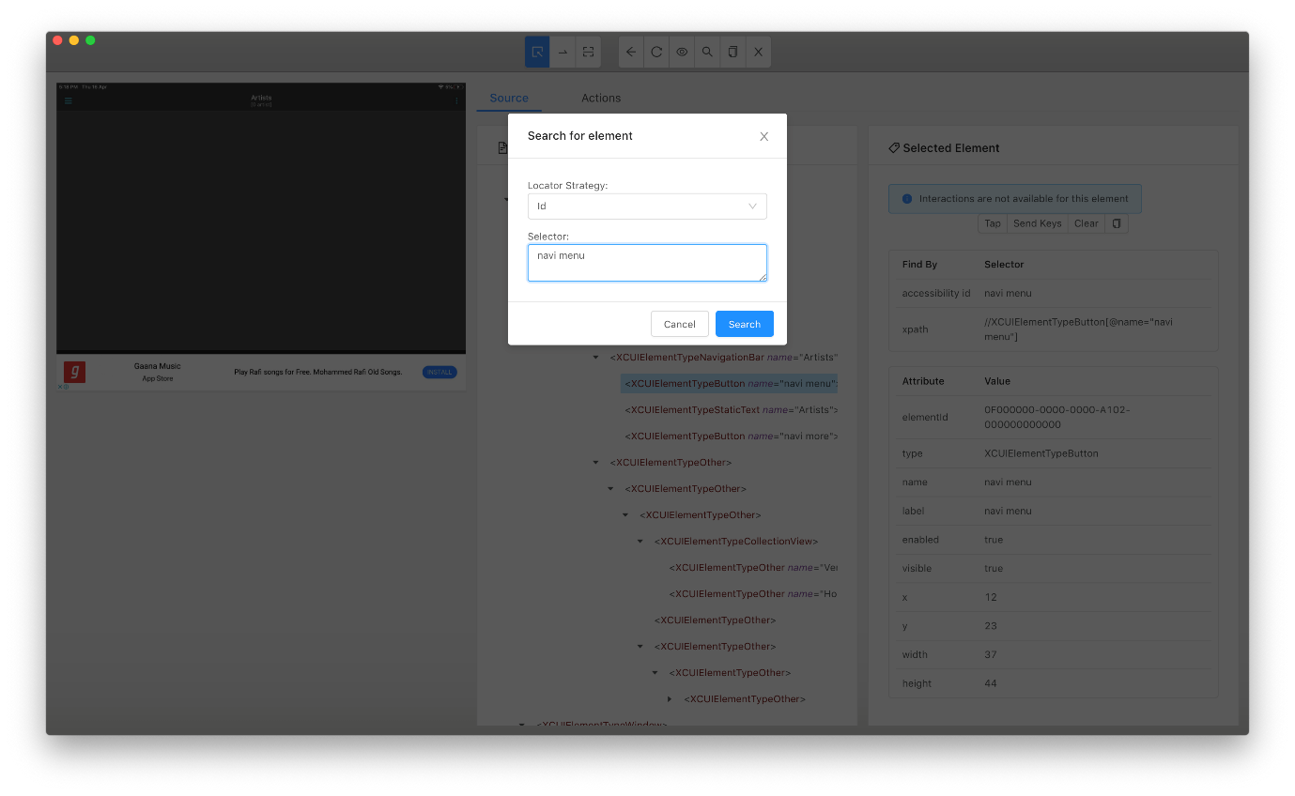
I have selected “ID” as a locator and entered the Selector as “navi menu” on click on “Search” button the next screen will appear if the given selector is valid and found in the screen. Inspector will always shows the elementID as a search result.

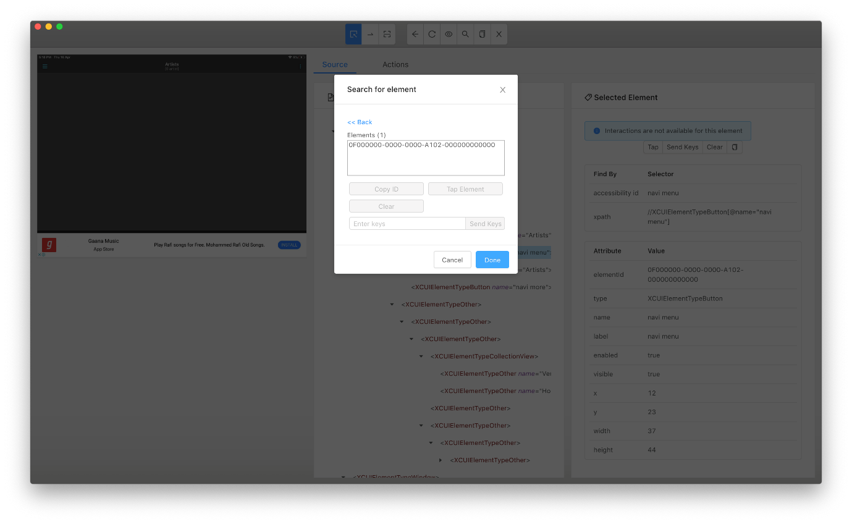
On clicking the elementID the searched element will get highlighted in the background screen so that we can recognize and confirm whether the highlighted element is what we are looking for.
